

Instrument Templates—User Guide

Document release 1.1

Updated April 2017

Contents

About this Guide 2

Download the templates from the OPC Website 2

Updating the Table of Contents (ToC) 3

Using the OPC styles 3

Showing the styles applied in Draft view 3

Showing the styles applied using the Apply Styles dialog 4

Showing tabs and paragraph marks 4

How to apply styles 4

How to apply a style using the Apply Styles dialog 5

Showing the Styles window 5

How to apply a style using the Style Window 5

No style available? 5

Some useful Word options 6

Prevent superfluous style names from appearing in the style list 6

Removing all character formatting 6

Installing the templates in Microsoft Word 7

Step 1A—Find the special templates paths (for Word 2010 or later) 7

Step 1B—Find the special templates paths (for Word 2007 or earlier) 7

Step 2—Choose which templates path you will use 7

Step 3—Copy in the templates 7

Step 4—Create a new document from the template 7

About this Guide

1. The purpose of this Guide is to assist users with the technical aspects of the instrument templates made available by the Office of Parliamentary Counsel (OPC).
2. The Guide provides essential information on:
   1. how to install the templates on your computer so that they are permanently available in Word;
   2. using styles to format your text;
   3. updating the table of contents.

Download the templates from the OPC Website

1. Use a web browser to go to the OPC website (www.opc.gov.au) and then click on the link for Client Information. Scroll down until you see the Drafting Templates section and then download each of the templates you need to your download folder.
2. After downloads have finished open the download folder so you can see the downloaded files.
3. If you want to make new documents double clicking on the template file on your desktop:
   1. just copy these files from the download folder to your desktop and you are done!
   2. you then just double click the template on your desktop and Microsoft Word will open and create a new document based on the template.
4. If you want to make new documents using the New Document button inside Microsoft Word, see the section on *Installing the templates in Microsoft Word* near the end of this document.

Updating the Table of Contents (ToC)

1. To update the ToC, right click on it anywhere and choose “Update Field” from the pop-up menu. This will usually present you with 2 options; “Update page numbers only” and “Update entire table” (see pic below).

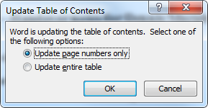

1. If you use the “Update page numbers only” option, any additional headings will not appear in the ToC.
2. You can also use the hyperlinks in the ToC to jump to the places in your document.

Using the OPC styles

1. Principal and amending instruments typically have more content than one page instruments. Use styles in these documents to quickly format your text and paragraphs to the correct formatting in order to keep your instrument formatting consistent.
2. For one page instruments, the correct styles have already been applied to the text that you edit. For these documents you do not need to apply styles to new blocks of text, and thus do not need to apply styles to text.

Showing the styles applied in Draft view

1. The Draft view in Microsoft Word has a feature called the “style area” that can be shown to the left of the text. This view is the best one for drafting longer documents with styles because you can see which styles are applied to the blocks of text.
2. The style area can be turned on by the following steps:
   1. clicking on the File tab
   2. choosing Options
   3. clicking on the Advanced section
   4. scrolling down to the Display section
   5. finding the “Style area pane width in Draft and Outline view” option and typing the number of centimetres you want. (see picture below)

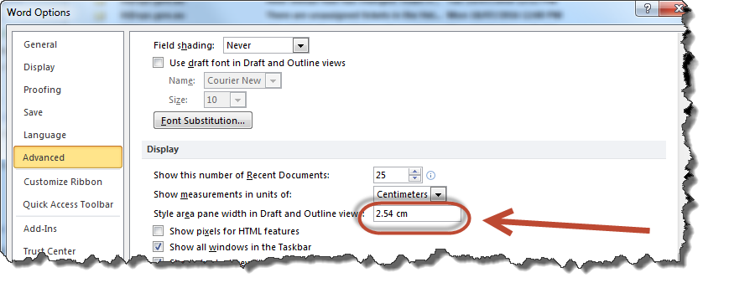

1. Once the style Window is shown, you can adjust its size by hovering the mouse over the vertical line to the right of the style area until the cursor changes to a double-headed arrow and then clicking and dragging it to the desired width.

Showing the styles applied using the Apply Styles dialog

1. You can also see the single style applied to the paragraph that the insertion point is in by using the Apply Styles dialog. You show this dialog by pressing **Ctrl + Shift + S**
2. The Apply Styles dialog “floats” over Word, so you can use this in the Print Layout view as well.
3. You can see the styles of different blocks of text by moving the insertion point using the mouse or keyboard, and the style shown will change to the style in use on the paragraph that the insertion point is in.

Showing tabs and paragraph marks

1. To make it easier to see where and how many tabs to use (such as for subsections), turn on the “Show paragraph marks” option using **Ctrl + \*** or click on the button in the Home tab on the ribbon as shown below.

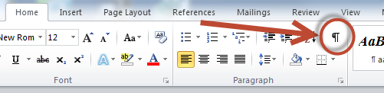

How to apply styles

1. There are several ways to show the list of styles available in a document, but OPC recommends that you use either the Styles window or the Apply Styles dialog.

How to apply a style using the Apply Styles dialog

1. First show the Apply Styles dialog by pressing **Ctrl + Shift + S**
2. Then to apply a style, click anywhere in a block of text or highlight multiple blocks of text and then choose the style you want to apply using the drop-down list.

Showing the Styles window

1. To show the Style Window, use the keyboard shortcut of **Ctrl + Shift + Alt + S**
2. Another way to show the Style Window is to click on the Home tab, then click on the little button in the Styles group area of the ribbon shown in the picture below.

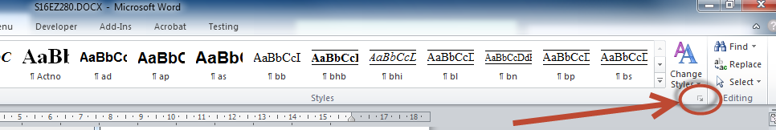

How to apply a style using the Style Window

1. To apply a style, click anywhere in a single block of text or highlight multiple blocks of text and then just click on the style you want in the Style Window.
2. Apply a style to format a new paragraph you have just made, or apply the same style to an existing paragraph to make the formatting go back to the style.
3. If you ever see the following dialog box when you apply a style, always choose the second option to reapply the formatting of the style (this is not the default option).

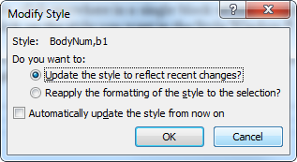

Note: If you accidentally click OK to the first option, every paragraph in your document with that style applied will have its formatting changed to match the format of the paragraph you were applying the style to. You can use the Undo feature to fix this.

1. The golden rule is: if the formatting of a block of text looks wrong, reapply the style.

No style available?

1. If there is no style available for the block of text you are using, have a look at precedents on the Federal Register of Legislation (if you open the Word document you should be able to see the style used).
2. You could also consider using the Normal style and formatting the text manually, or contacting OPC for complex drafting assistance.

Some useful Word options

Prevent superfluous style names from appearing in the style list

1. By default Microsoft Word keeps track of additions to style formatting and lists them in the style list. These superfluous names clutter the list making it hard to see the actual styles you want to use.
2. OPC recommend you disable the option using the following steps:
   1. clicking on the File tab
   2. choosing Options
   3. clicking on the Advanced section
   4. look in the Editing section at the top
   5. find the “Keep track of formatting” option and make sure it is not ticked.   
      (see picture below)

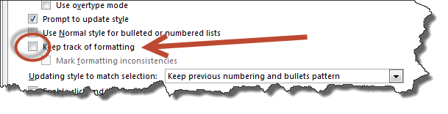

1. Once set, Word should remember this option for all documents.

Removing all character formatting

1. The “Ctrl + Spacebar” shortcut in Word removes all direct character formatting from the selected text. This can be a very useful shortcut when resolving formatting issues.

Installing the templates in Microsoft Word

1. To install the templates in Microsoft Word, first download the templates from the OPC website as described in the section called *Download the templates from the OPC Website.*
2. After downloads have finished open the download folder so you can see the downloaded files, then follow these steps:

Step 1A—Find the special templates paths (for Word 2010 or later)

* 1. on the File tab, click “Options”;
  2. click on the “Advanced” section heading;
  3. scroll the right side of the windows down to the bottom and click on the “File Locations...” button;
  4. look for the paths: WorkGroup templates and User templates.  
     Note: If *you cannot see the full path in the dialog box, double-click on template path to open the Modify dialog and then click in the drop-down list at the top of the dialog.*

Step 1B—Find the special templates paths (for Word 2007 or earlier)

* 1. on the Tools menu, choose “Options”;
  2. click on the “File Locations” tab;
  3. look at the path for: WorkGroup templates and User templates.  
     Note: If *you cannot see the full path in the dialog box, double-click on template path to open the Modify dialog and then click in the drop-down list at the top of the dialog.*

Step 2—Choose which templates path you will use

1. It makes no difference in Word which path is used. Sometimes organisations use the WorkGroup templates path for global document templates and prevent users from adding files to this path. Hopefully one of the paths will a place you can add files to.

Step 3—Copy in the templates

1. Use Windows Explorer to copy document template files to your chosen templates path from the downloads folder.  
   *Note: If you want to group them, you can make a folder inside the templates path and put them in there. Then the folder will appear as a tab in the new dialog in Word.*

Step 4—Create a new document from the template

1. You should now be able to create a new document at any time from the template in Word. Each new document you create from the template will be ready to save for the first time without risk of overwriting the template.
2. Open Microsoft Word and create a new document as follows:
   1. Microsoft Word 2013 and 2016:
      * 1. click the New button;
        2. click the “My Templates...” button option on the left;
        3. on the right side are 2 items (Featured and Personal), click on Personal
        4. either double click on the template or highlight it and click OK.
   2. Microsoft Word 2010:
      * 1. on the File tab, click the New option;
        2. click the “My Templates” button;
        3. either double click on the template or highlight it and click OK.
   3. Microsoft Word 2007:
      * 1. click the round Office button and click the New option;
        2. click the “My Templates...” button option on the left;
        3. either double click on the template or highlight it and click OK.
   4. Microsoft Word 2003:
      * 1. on the File tab, click “New...”;
        2. in the New Document pane, click the “On my computer” option;
        3. click on the correct tab (see step 3)
        4. either double click on the template or highlight it and click OK.  
           Note: If you put your templates in a folder in Step 3 above, the folder should appear as a tab in the Word New dialog, so click on the tab and then click on your template.